How Long Can a Facebook Reel Be? 2026 Limits and Best Run Times
Short answer: A Facebook Reel can now run past the old 90-second cap. Meta retired that limit in June 2025 when every Facebook video became a Reel, so uploaded Reels have no fixed maximum on updated accounts. Recording inside the Facebook app still stops at 90 seconds, and the minimum is 3 seconds.

Key Takeaways
- Uploaded Facebook Reels have no hard length ceiling anymore. The 90-second cap went away in June 2025.
- Recording in the app still stops at 90 seconds, so anything longer has to be uploaded as a finished file.
- The minimum is 3 seconds. SocialBee's direct publishing needs 4.
- Between 15 and 60 seconds still performs best for most business content.
- Facebook rewards completion, not duration. Cut to the length your point actually needs.
You cut a video and now you're checking whether it'll fit. That answer changed recently, and a lot of the advice still circulating was written before it did.

What's the Maximum Length of a Facebook Reel in 2026?
Two separate limits exist. One governs the video you upload from your computer, the other governs the video you record inside the Facebook app, and mixing them up is what causes most of the confusion online.
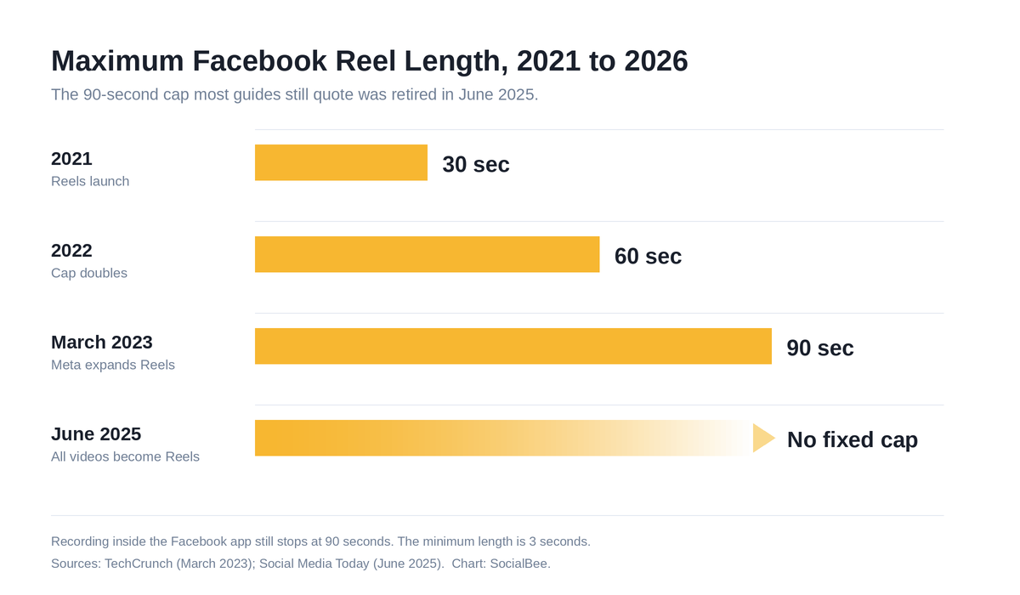
[Image source](https://socialbee.com/blog/facebook-reel-length/)

Uploaded Reels: No Fixed Cap
Upload a finished video file and Facebook no longer enforces a maximum duration. Meta confirmed in June 2025 that everything you post to Facebook except Stories and Live would publish as a Reel, and the 90-second restriction was dropped at that point. Horizontal footage gets shown in a vertical frame rather than refused.
Meta rolled this out gradually by region and account type, which is why two people on the same team can open the same composer on the same day and see different limits. If yours still rejects anything over 90 seconds, you haven't been switched yet.
TechCrunch covered the earlier jump to 90 seconds back in March 2023, and Social Media Today reported the 2025 consolidation that removed the ceiling.

Reels Recorded in the App: 90 Seconds
Recording works differently. Open the Reels composer and you're on a timer that still tops out at 90 seconds on most accounts.
Want a four-minute Reel? Film and edit it elsewhere, then upload the file.
[ IMAGE TO BE PLACED: images/facebook-reels-composer-timer.png ]
Alt text: The Facebook Reels composer with the 90-second recording timer visible above the record button
[Image source](https://www.facebook.com/)

The Minimum Length
Facebook needs 3 seconds. Below that, it won't publish. Scheduling tools set their own floor too, so check yours before you build a whole batch around a run time the tool won't accept. SocialBee's direct publishing to Facebook Pages takes 4 to 90 seconds at a 9:16 ratio, 540 x 960 or better, as an .MP4 or .MOV under 512 MB. Our free social media resources include planning templates.

How Long Should a Facebook Reel Be?
Being allowed to post a six-minute Reel doesn't make it a good idea.
For most business content, aim for 15 to 60 seconds. That's enough room to make one clear point without losing anyone before the end. Match the run time to the job instead of the maximum:
- Hooks and single tips: 7 to 15 seconds, with no setup.
- Product demos and how-tos: 30 to 60 seconds, enough for a real workflow.
- Explainers and interviews: 60 to 180 seconds, worth it only when your audience already knows you.
Padding is the mistake. A 45-second Reel stretched to 90 doesn't gain you 45 seconds of attention, it just gives viewers a clearly marked place to leave, usually right at the point where the video stops moving.

Does Reel Length Affect Reach on Facebook?
Not directly. Facebook doesn't rank Reels by how long they are.
It watches completion.
A 25-second Reel that most viewers watch to the end sends a far stronger signal than a 90-second one that sheds half its audience in five seconds. Shorter Reels win because short videos are easier to finish, which is a different thing from the algorithm preferring them. Our breakdown of the Facebook algorithm covers what else gets weighted.
Then check your own numbers, because none of this beats your own data: sort your Reels analytics by average watch time, find where the drop-offs cluster, and cut to just before that point.

Facebook Reel Specs to Check Before You Post
A Reel of exactly the right duration will still get rejected, or publish looking soft and blurry, if the file doesn't meet spec.
[ IMAGE TO BE PLACED: images/socialbee-facebook-reel-scheduled.png ]
Alt text: A Facebook Reel scheduled inside the SocialBee post editor with the preview panel open
[Image source](https://socialbee.com/)
Spec | Requirement
Length, uploaded | 3 seconds minimum, no fixed maximum on updated accounts
Length, in-app recording | 90 seconds maximum
Length, SocialBee direct publishing | 4 to 90 seconds
Aspect ratio | 9:16 vertical
Resolution | 1080 x 1920 recommended, 540 x 960 minimum
File size | Under 512 MB for direct publishing
Format | .MP4 or .MOV

Posting across several platforms? Every one of them wants something slightly different, and our guide to social media video sizes lists the lot.

How to Schedule Facebook Reels With SocialBee
Length decisions get easier when you aren't posting in a rush.
SocialBee publishes Reels straight to your Facebook Pages, so you can queue a 12-second hook for Tuesday and a 60-second demo for Thursday without opening the app twice. Preview each one before it goes out, then drop it into a content category so your posting mix stays balanced. Personal profiles get a mobile notification at post time, caption copied and file ready.
Here's the full walkthrough: how to schedule Reels on Facebook.

Frequently Asked Questions About Facebook Reel Length
Can a Facebook Reel be 3 minutes long?
Yes, if you upload it as a finished file and your account has the June 2025 update. The in-app camera still won't record that long.
What's the shortest a Facebook Reel can be?
3 seconds. Through SocialBee's direct Facebook Page publishing, 4 seconds.
Why does my Facebook Reel still cap at 90 seconds?
Your account probably hasn't received the change yet. Upload a finished file rather than recording in the app, and check whether you're posting to a Page or a personal profile.
Do longer Facebook Reels get less reach?
Not because of their length. Fewer people finish them, and completion is what Facebook rewards.
Is there a length limit for Facebook Reels ads?
Meta publishes no maximum for the Reels placement. Keep ads under 30 seconds regardless, because a cold audience gives you very little patience.
Can I post a horizontal video as a Reel?
You can, and it'll publish. It gets shown in a vertical frame, so shoot 9:16 when you have the choice.

Getting Facebook Reel Length Right
The Facebook Reel length limit is looser than it's ever been, which is a mixed blessing. You have room for a longer story now, but the Reels that travel furthest are still the ones people finish.
So let the message set the length. Your watch-time data will tell you where people leave, and that number is worth more than whatever ceiling Facebook happens to allow this year.
Ready to stop posting Reels one at a time? Start your 14-day free SocialBee trial and schedule a month of Facebook Reels in an afternoon. No credit card needed.

